**May 2014 HL P1**

**Section A**

1. Identify **two** features that need to be considered when planning a new computing system for

an organization. [2]

*Award up to* ***[2 marks max]****.*

Roles/activities of the users (*eg* permissions, security, partitions, collaborative work);

Resources (HW and SW equipment) appropriate for the organization;

Costs/budget limits;

Delivery time;

Compatibility with the old system (data);

*(Other acceptable answers are possible, from the economic, operational and technical*

*perspective.)*

1. Explain what is meant by beta testing. [2]

*Award up to* ***[2 marks max]****.*

Testing prior to product’s full release / last stage of testing;

To see if it works properly / complete functionality / usability;

Performed by end users (not by designers);

1. Describe **one** advantage and **one** disadvantage of using observations to gather information

when planning a new system. [4]

*Award up to* ***[4 marks max]****.*

*Award* ***[1 mark]*** *for the identification of an advantage and* ***[1 mark]*** *for explaining the*

*advantage.*

*Award* ***[1 mark]*** *for the identification of a disadvantage and* ***[1 mark]*** *for explaining the*

*disadvantage.*

*Example Advantages:*

Can highlight aspects that are not detected in questionnaires/interviews;

So the observer can help produce more detailed reports;

Observations may be more reliable than interviews;

Because they can reveal what people actually do instead of what they say they do;

*Example disadvantages:*

Time consuming / expense;

The observer might need to observe a complete cycle *etc* which could last a significant

amount of time;

If the observations are made by only one person, they may be biased;

Observations may be unreliable;

Because people act differently when they know they are being watched.

*(Accept formulations that express similar or plausible ideas.)*

1. Outline **one** usability issue associated with the design of mobile devices. [2]

*Award* ***[1 mark]*** *for identifying an issue and* ***[1 mark]*** *for an explanation.*

Size of screen;

Therefore difficult to see / use (in poor light);

Size of keys;

Therefore difficult to access functions;

Battery life;

May need to recharge regularly;

Touch screen keys on tablets *etc*;

Lack of tactile feedback;

1. Distinguish between the use of **two** types of primary memory. [2]

*Award up to* ***[2 marks max]****.*

*Award* ***[1 mark]*** *for identifying* ***two*** *types of primary memory.*

*Award* ***[1 mark]*** *for the use of* ***each*** *type of the memory identified ×2.*

RAM stores data and instructions currently in use

ROM stores permanent instructions

Cache stores frequently used instructions

*(Award* ***[1 mark]*** *if only general scheme of CPU is given.)*

1. Consider the following linked list which is maintained in alphabetical order.  
     
   With the aid of diagrams, explain how the node  
     
     
   would be inserted into the linked list. [3]

Initially compare with node pointed to by the head;

(If not correct place) move through list using pointers until correct alphabetical position

is found;

Adjust pointers accordingly;

*(Drawings are acceptable, but award marks only if they clearly show how pointers are*

*correctly rearranged, following the three guidelines above.)*

1. Outline how a colour can be represented in a computer. [2]

A colour will be split into three components *(Accept RGB as an example)*;

Each component will be assigned a certain number of bytes;

1. Identify **two** key features of a peer-to-peer (P2P) network. [2]

*Award up to* ***[2 marks max]****.*

*Examples of features:*

No central server;

Resources are more widely available (storage, bandwidth, computing power);

Redundancy/recovery;

Supports file sharing for collaborative work;

1. Outline the role of paging in the management of primary memory. [2]

*Award up to* ***[2 marks max]****.*

It is used in the formation of virtual memory / use of secondary memory;

To increase the amount of primary memory;

Memory divided into (tagged) “pages”;

Which are then transferred in and out as required;

1. Outline **two** distinct features of autonomous agents. [4]

*Award* ***[1 mark]*** *for a feature and* ***[1 mark]*** *for a description, for two features, up to*

***[4 marks max]****.*

*Feature:* Autonomy;

*Description:*

Agents *activate* alone for a task and are not invoked for a task;

Agents can *select the task* themselves (based on priorities or goal-directed search)

without human intervention;

*Feature:* Reactive behavior;

*Description:*

Agent senses the environment in which it is, and decides what to do reacting on its

perceptions;

*Feature:* Concurrency/sociality;

*Description:*

Agents can interact with other agents through communication, in different modes:

coordination, cooperation, competition;

*Feature:* Persistence;

*Description:*

The code describing an agent runs continuously like a process, and is not executed on

demand;

**Section B**

1. A builder is renovating a series of apartments and is considering integrating a few electrical

devices in each apartment into an automatic programmable system. One example is the

integration of lighting, heating, ventilation and air conditioning.

1. Identify **two** groups of users that might find this integrated technology

particularly appealing. [2]

*Award up to* ***[2 marks max]****.*

Elderly;

Disabled;

Commuters;

*Accept other reasonable answers.*

1. Discuss **two** advantages, offered by this technology, that could be used in an advertisement

for the apartments. [4]

*Award* ***[1 mark]*** *for advantage and* ***[1 mark]*** *for explanation, for two items, up to*

***[4 marks max]****.*

Improved convenience;

One can better control times of functioning, hence costs;

Improved comfort;

One can program the functions according to their specific needs;

Energy efficiency;

One can program/plan the functions based on the surrounding environment and

reduce energy waste (interconnected systems);

Safety;

Programmed in a way to avoid electric overload and faults;

*Accept other reasonable answers*

1. Evaluate **two** ways users can access the functionality of the integrated system at home. [6]

*Award up to* ***[6 marks max]****.*

*Award up to* ***[3 marks max]*** *for each of the two ways.*

*Award* ***[1 mark]*** *for the way of access and up to* ***[2 marks]*** *for two additional*

*points, which could be advantages or disadvantages.*

*Examples include fixed/non-fixed installations, digital/analogue.*

Computer based/TV-based control;

The user always knows where the control is;

Because the device may not be portable;

Inconvenient if computer/TV already being used by someone else;

Touch screen/keypads in fixed installation;

Ergonomic gadget/small dimensions/cheap device;

Wide range of different designs to fit different locations in a house;

Difficult to lose;

Inconvenient to operate some devices by having to go to a fixed panel/not suitable for

extended use to operate TVs etc;

Smartphone;

Portable/useful for some groups of users (limited mobility);

Can be easily extended to include other devices;

Could be lost or misplaced;

Requires internet/Wi-Fi/signal to operate;

*Accept other suitable answers.*

The same technology is adapted and used for intensive chicken farming; in this context a  
 decentralized control is preferred.

1. Describe how this could be achieved. [3]

*Award up to* ***[3 marks max]****.*

Transmission: integrated wiring or internet or wireless;

Requires: extended/dedicated network and hw/sw for protocols/transmissions and

sensors/actuators;

Use: The farmer can vary the parameters/environmental conditions from home at

any time and better concentrate on other activities (*eg* trade with KFC);

1. An international organization has offices located across several countries. For some of

its activities, for example human resource management, it has been decided to adopt a

“Software-as-a-Service” (SaaS) solution in order to keep the running costs low.

1. Describe the features of SaaS. [3]

SW necessary for the activities is in the cloud;

Access to SW is with thin client (terminal/computers) by web browsing (on the

extranet);

1. Discuss the limitations of SaaS in relation to security. [6]

*Award up to* ***[6 marks max]****.*

Security in storage;

Data is stored in the server of the service provider;

The organization has no direct control of its data;

Legislation in the country of the provider may be weaker than in the user’s

country;

Cases of provider’s corruption/bankruptcy/data loss are a risk to the

organization;

Security in transmission;

Applications running in-site may require data in SaaS;

Hence longer transmission times and higher risk of

failure/attack/interception;

Each office makes some data available to external customers through the use of an extranet

and allows employees to work from home through a VPN.

1. Define the term extranet. [2]

*Award up to* ***[2 marks max]****.*

An external extension to a company’s local network;

Limited access;

Uses internet protocols;

1. Distinguish between a VPN and an extranet. [4]

VPN authenticates the sender before (establishing the tunnel);

VPN access is always encrypted, whereas extranet has limited encryption;

VPN transmission is always encrypted;

VPN users have access to everything whereas extranet users only have access to

(enabled) specific services;

1. The faceplate of a car stereo has six buttons for selecting one of six preferred radio stations.

As part of the internal representation of a microprocessor there is an array with six positions,

carrying the information about the radio frequencies, as follows.

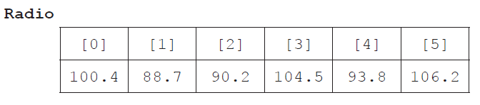

1. State the information at Radio[2]. [1]

90.2

1. Outline how a numerical frequency could be stored in a fixed-length string. [2]

Frequencies less than 100 take a 0 on the left (*eg* 88.7 becomes 088.7);

Convert each digit into a char to get a string;

*Allow the “dot” to be omitted in the interpretation. There is always only one*

*decimal in the example.*

1. Construct an algorithm in pseudocode that calculates the range of frequencies

(ie the difference between the highest and lowest frequencies) of any set of six selected

radio stations. [6]

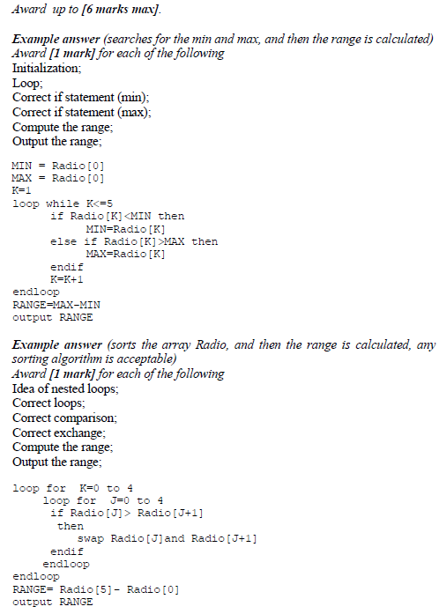

The two-dimensional array Stats provides an indication of how often a specific station is

listened to by the user. For each button in the faceplate it records how often it has been clicked

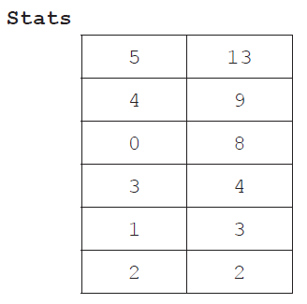 in the last 48 hours. Stats is ordered by the second column.

Both Radio and Stats are used by a procedure that allows the user to access the radio frequencies

that are listened to most often, as recorded in Stats, by flicking a lever on the steering wheel.

The frequencies are accessed cyclically, ie after the least used frequency the procedure returns

to the most used. For this reason a queue **Q** is used.

1. Construct an algorithm in pseudocode that, by using the structures Radio and Stats,

performs the following steps:

* it inserts the radio frequencies in the queue **Q**, following the actual order of preference;

and then

* it uses the queue **Q**, cyclically, to output an element each time the lever is flicked. [6]

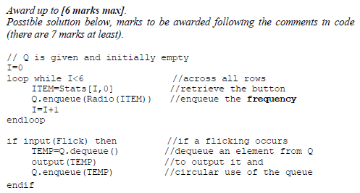

1. Consider the following diagram and pseudocode for drawing on a display screen.

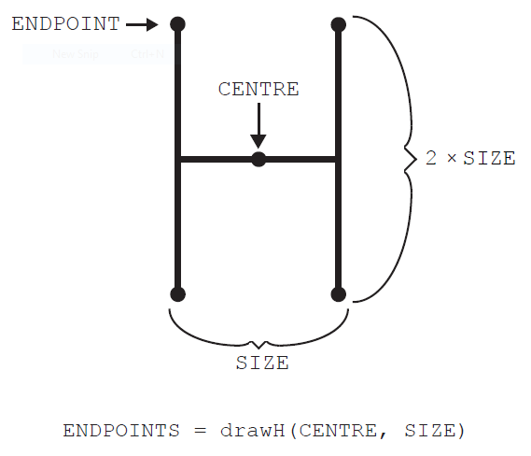

The method drawH(CENTRE, SIZE) will draw an “H” located at CENTRE with width of SIZE

and height of 2 × SIZE, as shown. It returns an array containing the four **endpoints** of the

vertical lines.

In the following flowchart, POINTS1 is a stack.

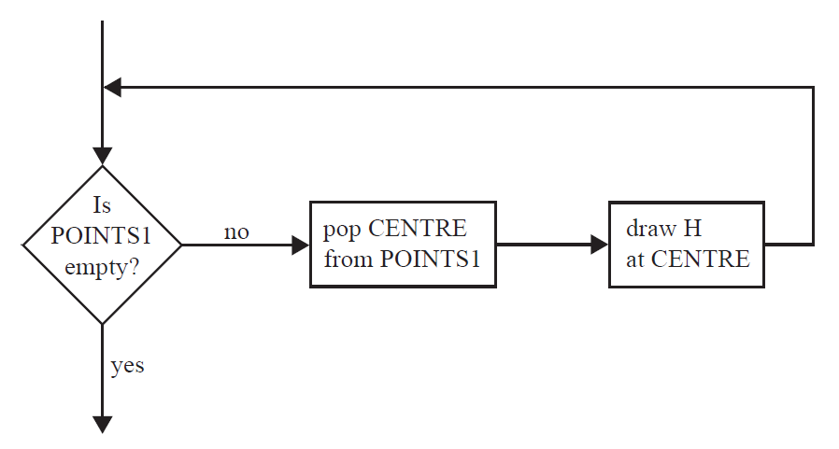

1. Construct pseudocode corresponding to the flowchart. [3]

*Award up to* ***[3 marks max]****.*

*Award* ***[1 mark]*** *for a loop (while).*

*Award* ***[1 mark]*** *for correct condition/logical expression.*

*Award* ***[1 mark]*** *for correct operations.*

loop while NOT POINTS1.isEmpty()

CENTRE = POINTS1.pop()

drawH(CENTRE, SIZE)

end loop

1. Construct the drawing that would be produced by the flowchart on page 6 if it is preceded

by the following steps.

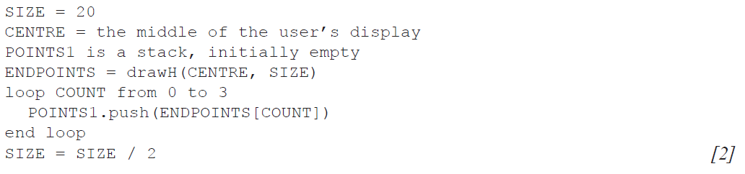

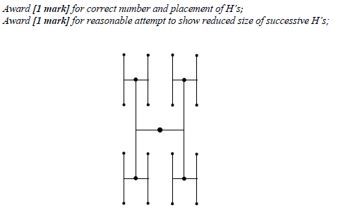

The pattern of drawing a new set of H’s, which have a SIZE value that is half the SIZE value

of the previous H, can be repeated. Each set of H’s of the same size is called a generation.

1. Construct an algorithm that will draw an initial H in the centre of the display and three

generations after that. [6]

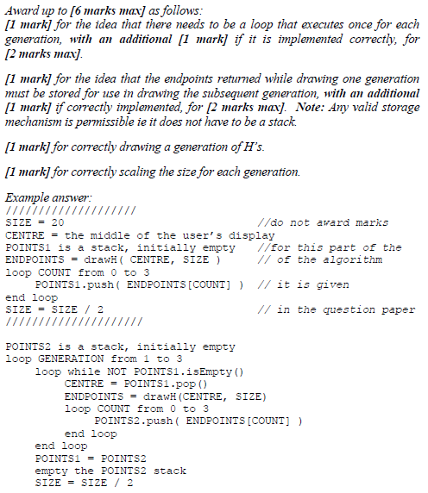

1. State how many endpoints there will be after the initial H and three generations have been

drawn, without any consideration of the size. [1]

*Accept any expression appearing in the following equivalences*

4*4*4*4 = 44 = 256;

1. Suggest how drawing this pattern of H’s could be done recursively. [3]

*Award up to* ***[3 marks max]*** *for:*

*identifying that the recursive algorithm proceeds downwards (showing on one*

*parameter will suffice);*

*base case of recursion;*

*recursive call;*

The recursive algorithm would use the parameters centre, size, generation

counting down (not up);

When the generation reached is 0 no drawing is done;

Otherwise draws an H and calls recursively itself on the endpoints of a lower

generation;

1. A suburban railway system for a large city in Southern Europe consists of two lines **L1** and **L2**,

which meet at the station Centro, where passengers can change from one line to the other.

The system is shown below.

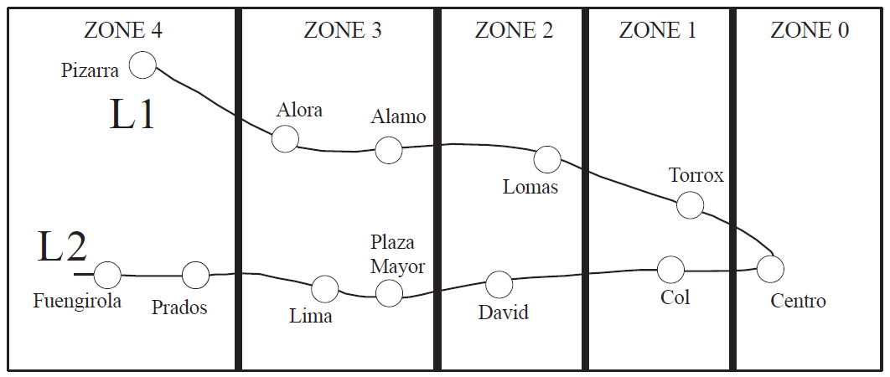

Each station is located in a particular zone, and the total number of zones in which the journey

takes place determines the train fare. Note, if a passenger starts in **Zone 1**, goes to **Zone 0** and

then back to **Zone 1**, the journey has taken place in **three** zones. Examples of the number of

zones are shown below for different journeys.

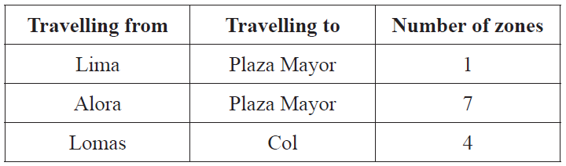

1. State the number of zones in which the journey takes place when travelling from Alora

to Fuengirola. [1]

8;

The data for each station (station name, line, zone) is stored on the system’s server in the

collection TRAIN_DATA. There are 12 stations in total. The first part of the collection is

shown below.

Centro, L1, 0, Alora, L1, 3, Torrox, L1, 1, Col, L2, 1, ...

From this we can see that Alora is part of line L1 and is located in Zone 3.

At the start of each day, the data in TRAIN_DATA is read in to the binary tree TREE, in which

each node will hold the data for one station. The binary tree will be used to search for a specific

station’s name.

1. Sketch the binary tree after the station data from the first part of the collection,

given above, has been added. [3]

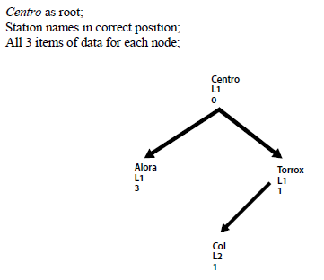

The TRAIN_DATA collection is also used to construct the one-dimensional array

STATIONS (which only contains the list of station names sorted into alphabetical order),

where STATIONS[0] = Alamo.

1. State the value of STATIONS[4]. [1]

David;

The two data structures (STATIONS and TREE) are now used to construct the two‑dimensional

array FARES containing the fares between stations, partly shown below. Note that the fare for

travelling in each zone is €1.00.

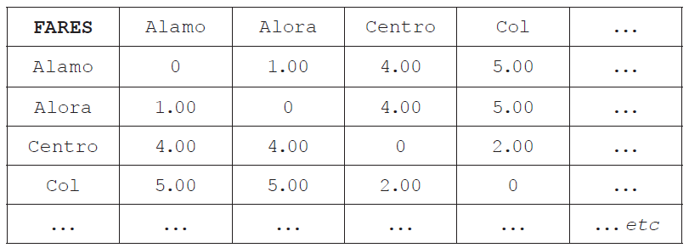

1. Calculate the fare for travelling from Torrox to Lima. [1]

5.00 (Euros);

*Accept 5.*

1. Construct the algorithm that would calculate the fares for this two-dimensional array.

You can make use of the following two sub-procedures:

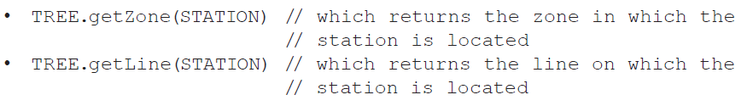

Your algorithm should make as few calculations as possible. [9]

